**VIT-AP UNIVERSITY, ANDHRA PRADESH**

**CSE3003 – Computer Networks - Lab Sheet: 6**

**Academic year:** 2023-2024  **Branch/ Class:** B.Tech

**Semester:** Fall  **Date:**

**Faculty Name:** Prof. S.Gopikrishnan  **School:** SCOPE

**Student name:22BCE7224 Reg. no.: 22BCE7224**

**LAB 6**

1. Design a network using fixed length Subnetting for a class C Ipv4 address and configure it in Router.

192.168.10.0/28

1. Mention the subnet masks of the above-mentioned IP Addresses

Ans. 255.255.255.240

1. Find the total number of subnets for each ip addresses

Ans. 2^4=16

1. Find the total number of hosts that can be configured.

Ans. 2^(32 - 28) - 2 = 2^4 - 2 = 14 hosts per subnet.

1. Find out the broadcast ID for each of the IP addresses

Objectives:

1. Design the above network with packet tracer.
2. Each subnet should have two PCs (one for starting address and one using ending address.
3. Configure first 4 subnet as single network as below.
4. Show output of router config, pc’s ip config and success message.

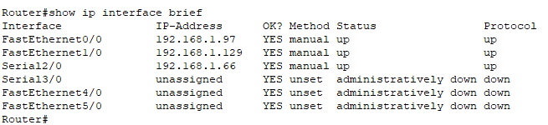

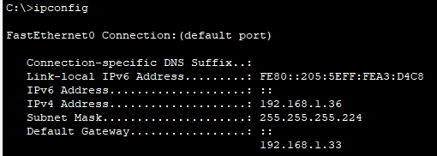

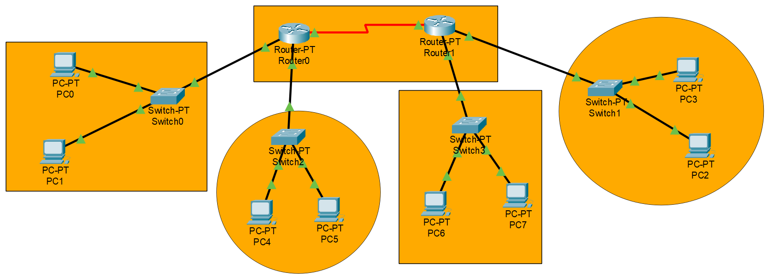

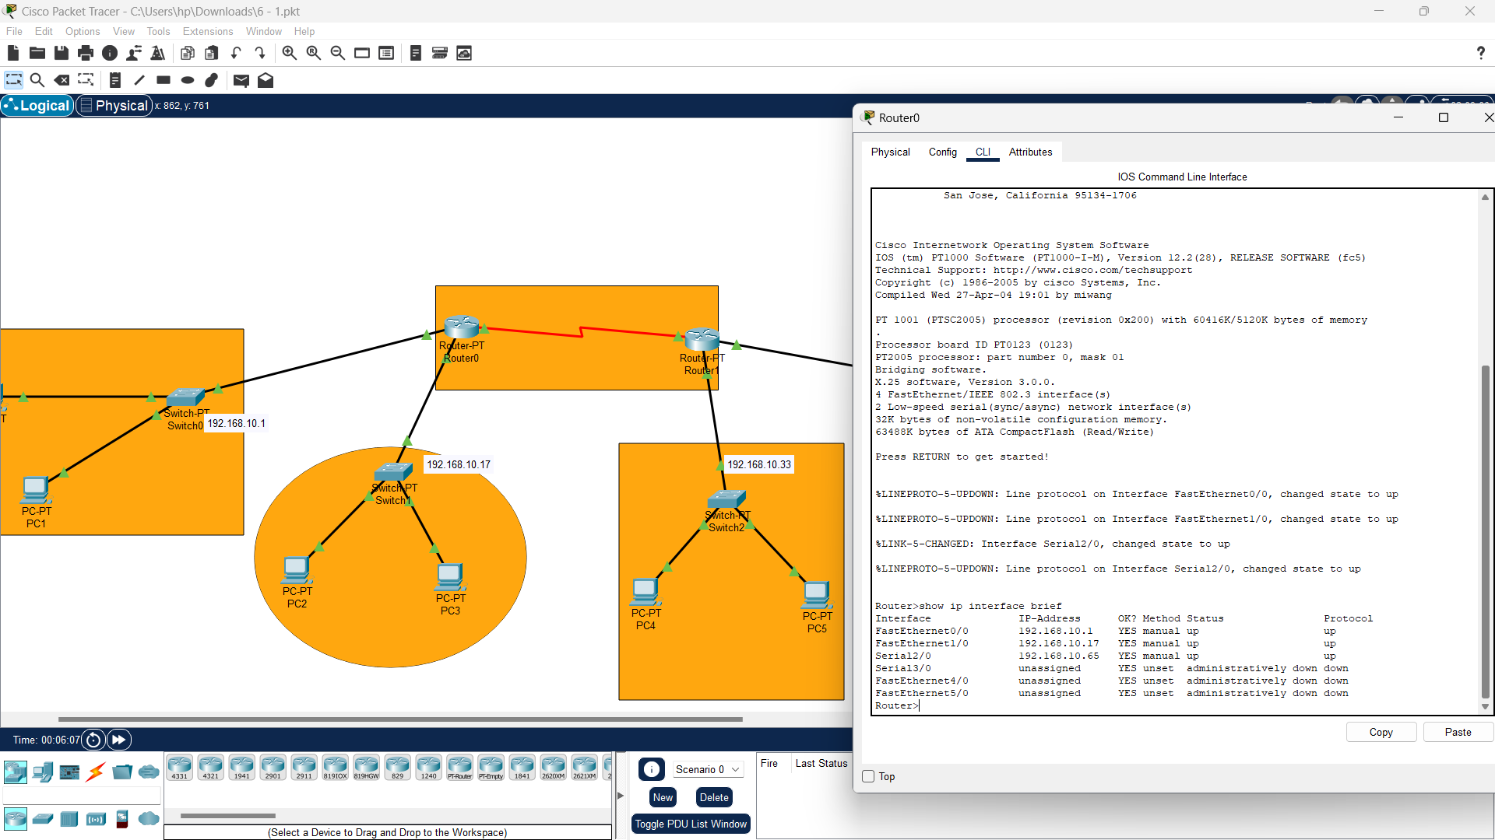

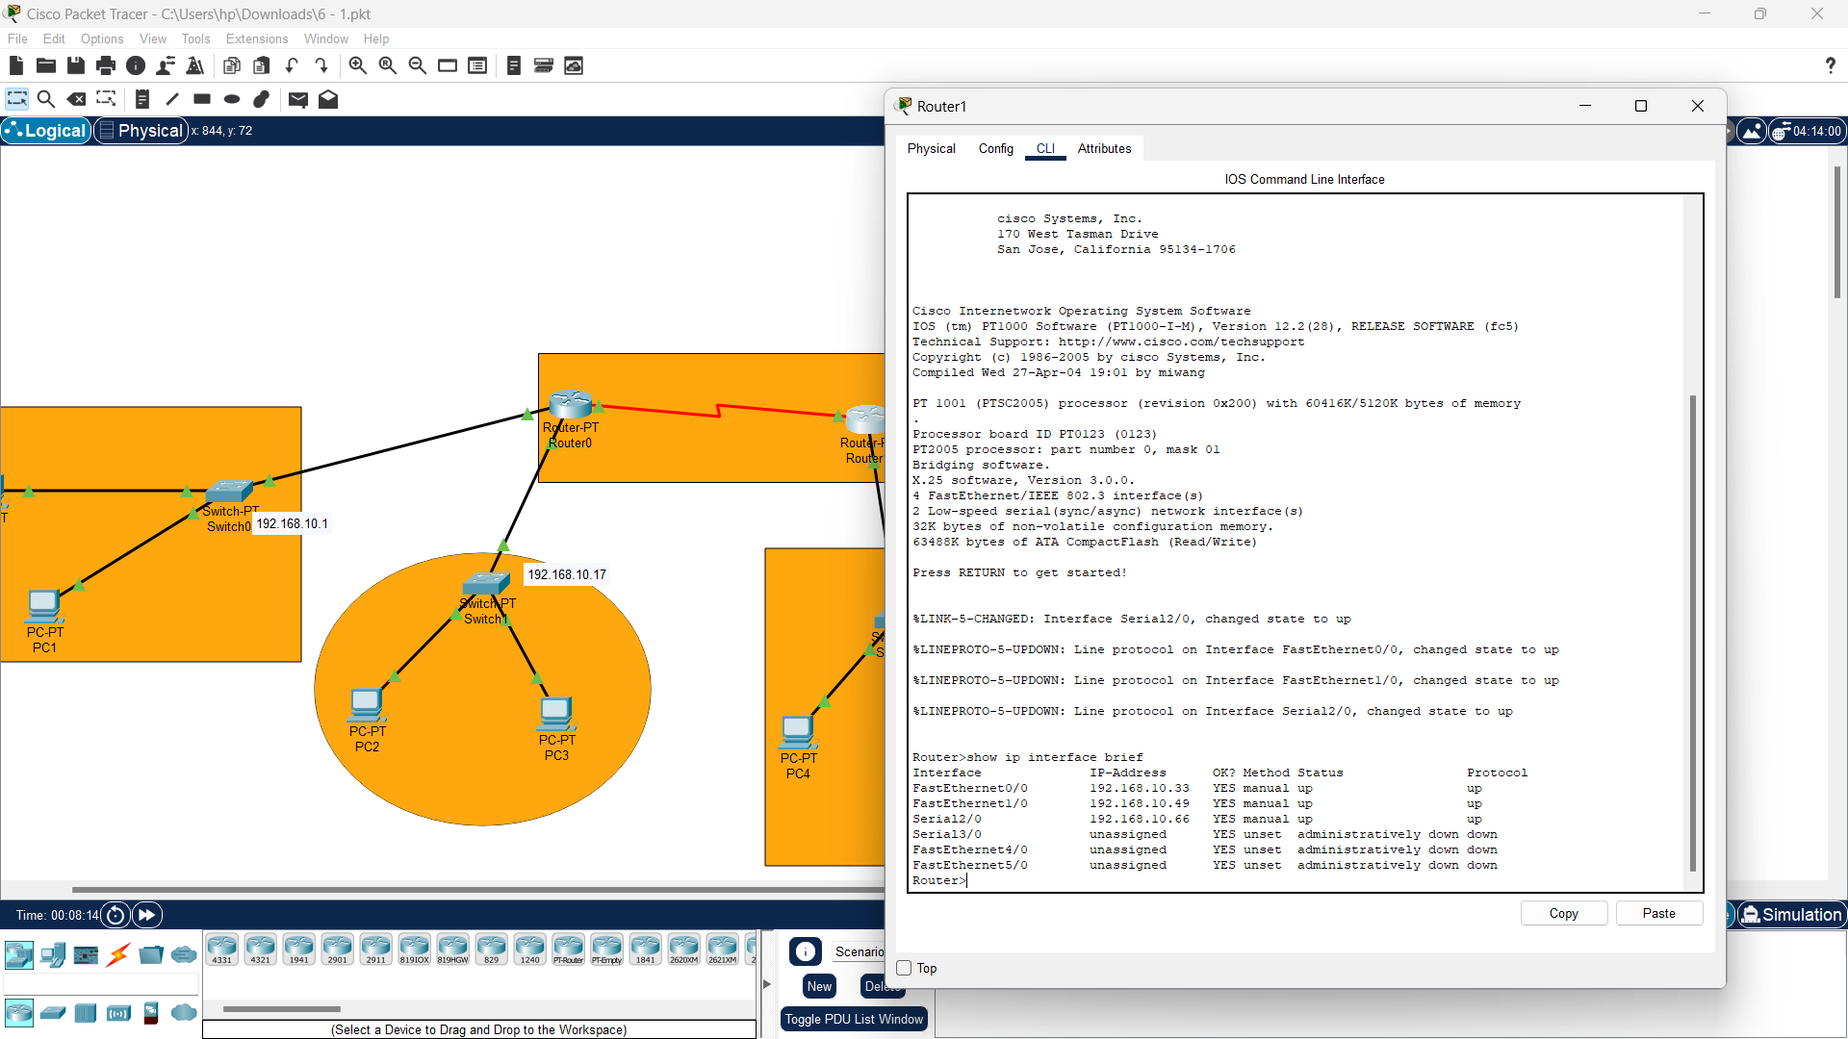

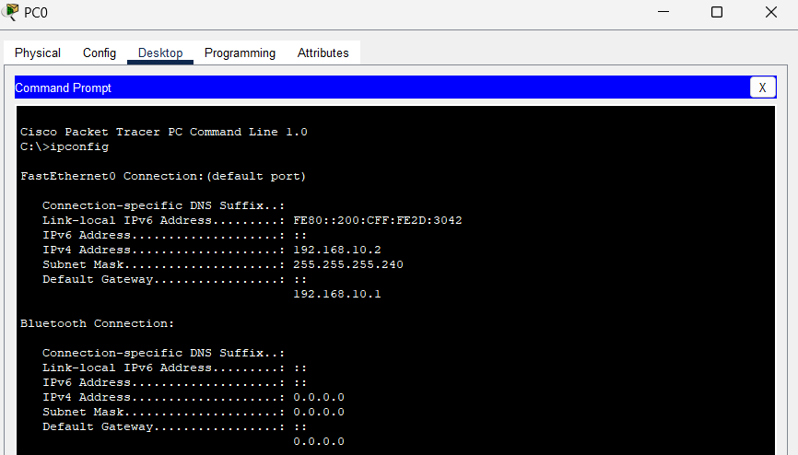

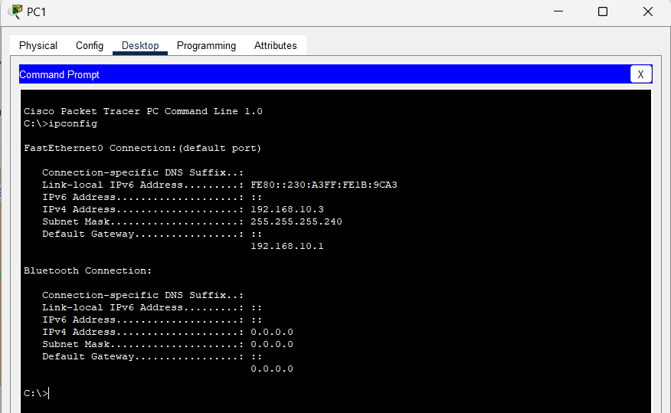

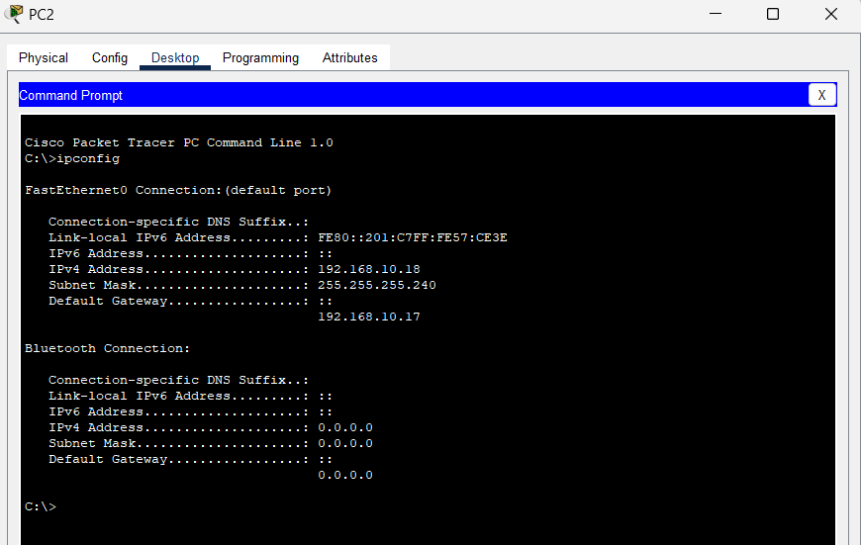

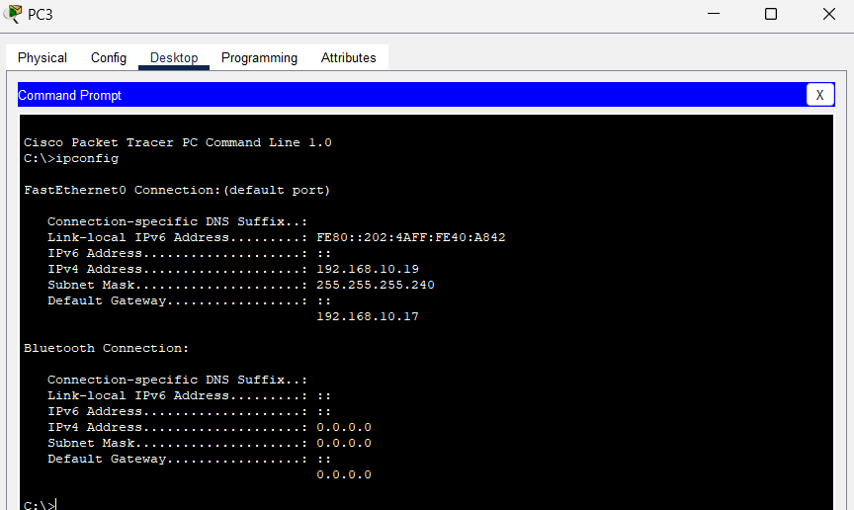

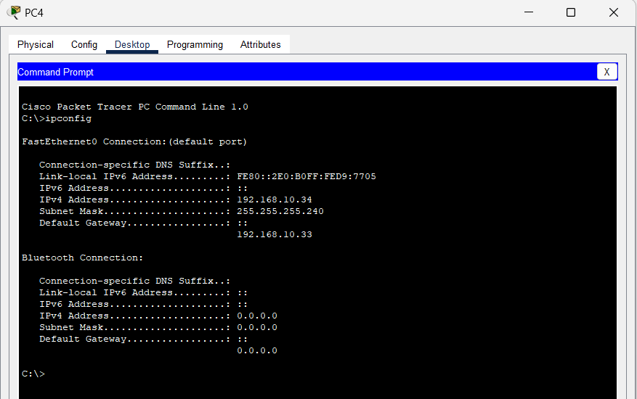

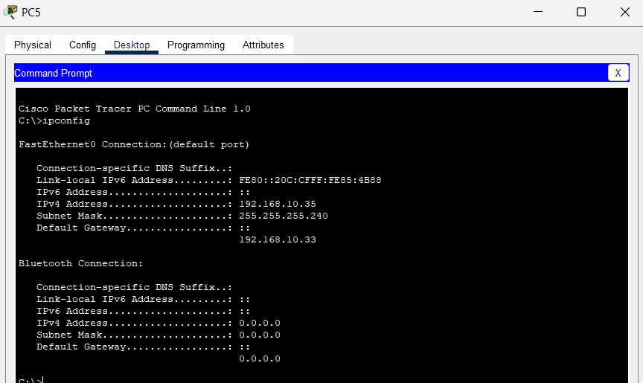

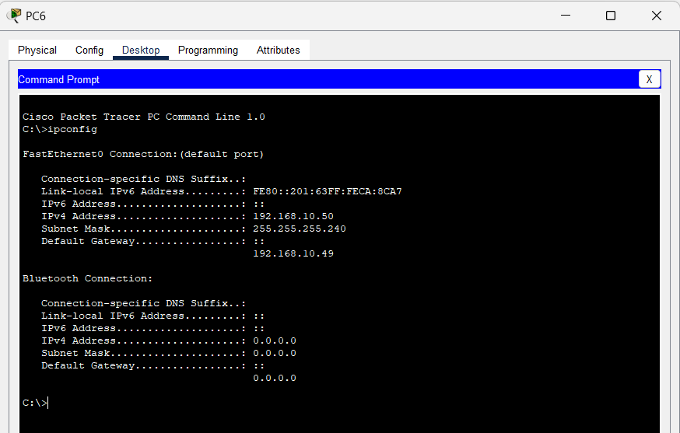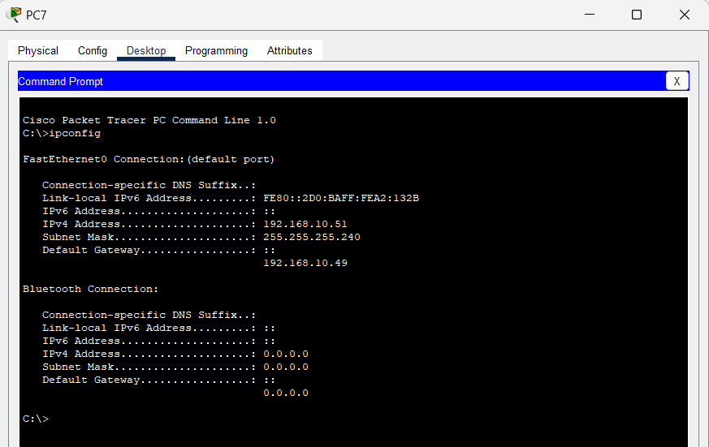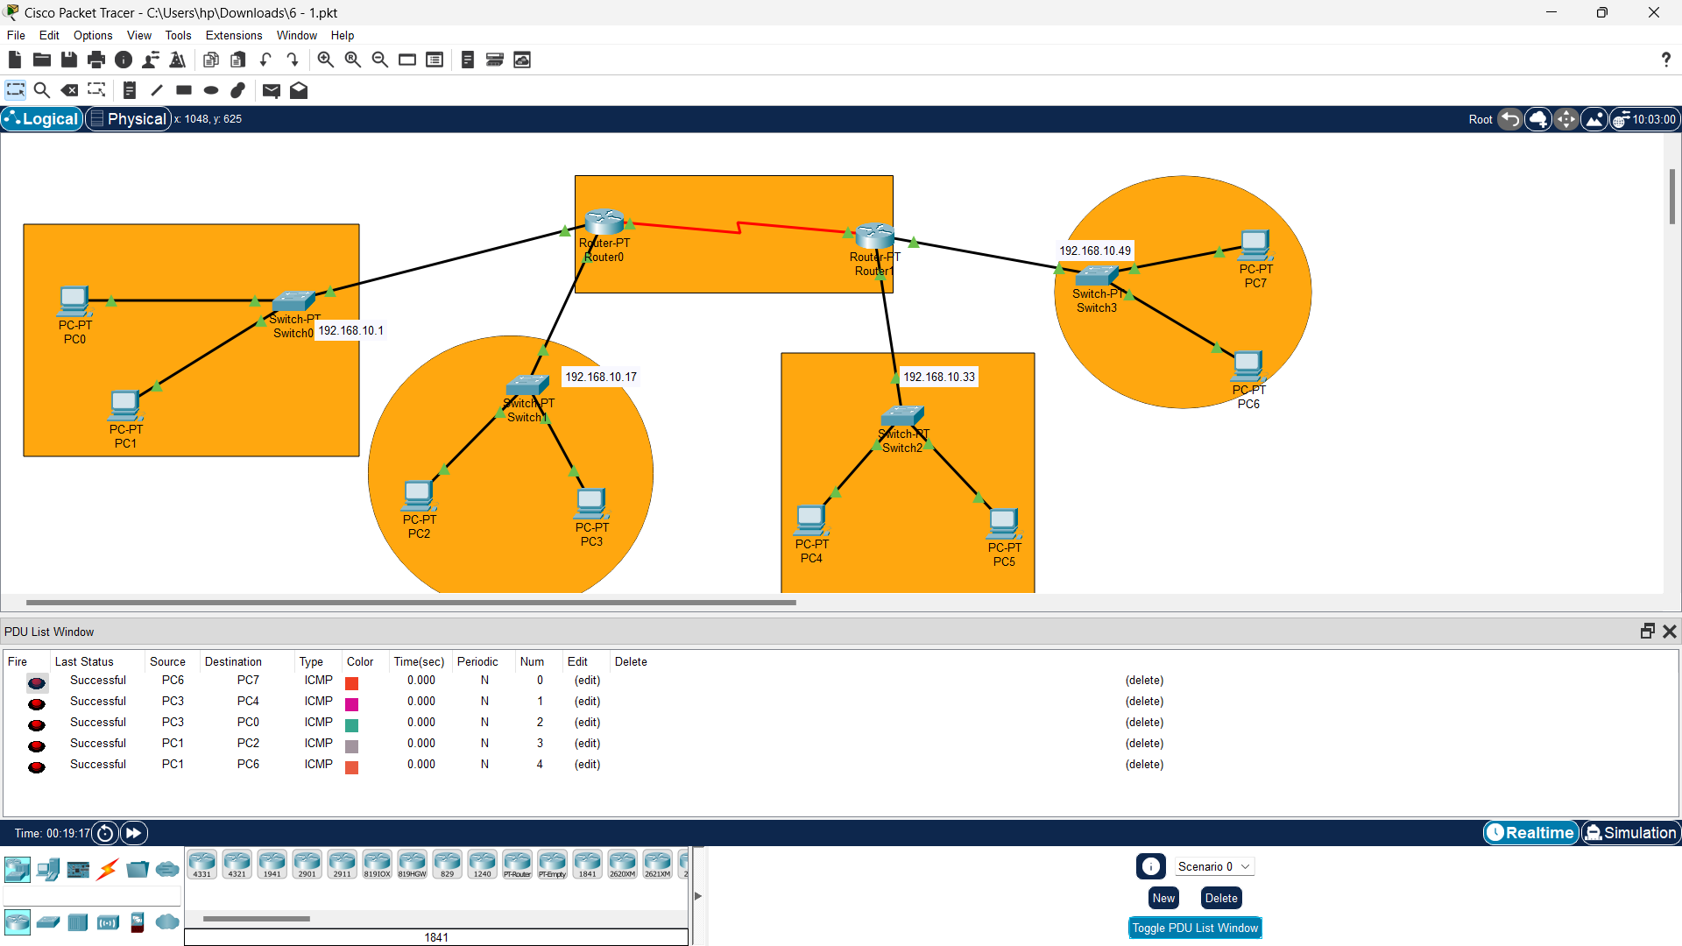2.Design a network using fixed length Subnetting for a class B Ipv4 address and configure it in Router.

172.168.1.0/17

1. Mention the subnet masks of the above-mentioned IP Addresses

Ans. 255.255.128.0

1. Find the total number of subnets for each ip addresses

Ans. 2^(17-16) = 2

1. Find the total number of hosts that can be configured.

Ans. 2^(32 - 17) - 2 = 2^15 - 2 = 32,766 hosts per subnet.

1. Find out the broadcast ID for each of the IP addresses

172.168.127.255

Objectives:

1. Design the above network with packet tracer.
2. Each subnet should have two PCs (one for starting address and one using ending address.
3. Configure first 4 subnet as single network as below.
4. Show output of router config, pc’s ip config and success message







